2012

The Russian Exhibition Centre
Russia, Moscow

DIPLOMA and Gold Medal “The Winner of REC”
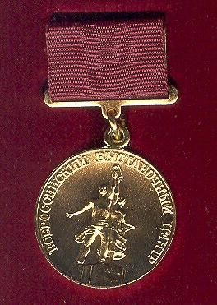

2-nd International Specialized Exhibition-Fair
"Our country-house”
Russia, Moscow

DIPLOMA
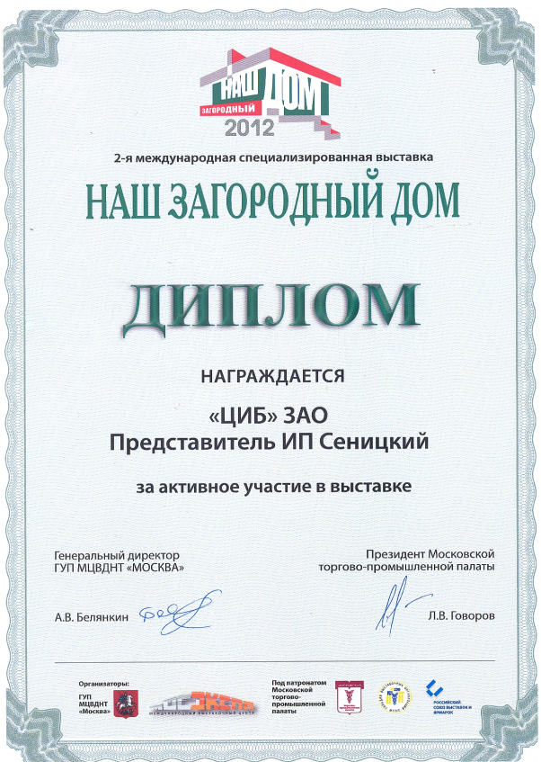

16-th specialized exhibition fair "Country-house. Garden. Landscape. Small mechanization – 2012”
Russia, Moscow

DIPLOMA for production of high-quality natural fertilizers
